NOOR FATEHAH BT. MUSTAFFA

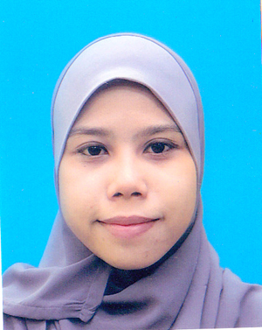

* Address : Lot 1042/2B Jalan Tg Syawal,Sg Pinang,41400 Klang
* Mobile No : +60122483770
* Email : n_teeya1304@yahoo.com

RELATED COURSE

|  |  |
| --- | --- |
| * Financial | * Facilities Management |
| * Insurance in Construction | * Maintenance |
| * Design | * Quantity Survey |
| * Safety & Health Officer | * Construction |

HIGHLIGHT

|  |  |
| --- | --- |
| * Auto CAD 2010 | * Skill in Photoshop |
| * Revit | * Good Communication |
| * Microsoft Word/Excel/Power Point | * Work in a team |
| * Project Manager | * Positive think |

EXPERIENCE

Project Manager

* Having an experience as project Manager in “Fajar Sadiq Resources” to conduct some project such as cleaning, repairing and a landscaping.
* Prepare report about project
* Need to manage workmanship
* Experience in 1 years
* Salary : RM 1,800.00

Service Coordinator

* Has an experience as Service Coordinator at Infoview Lifetime Sdn Bhd
* Need to arrange schedule for technician
* Need to deal and contact client about condition product
* Need to prepare report status of labor and total job per day
* Need to prepare summary cost for service call, new job and follow job.
* Need to manage technician
* Salary : RM 1,800.00

EDUCATION

* Bachelor of Building Surveying, Hons UiTM Shah Alam
* Diploma in Building Surveying, Sri Iskandar UiTM
* SPM at Methodist Girl School, Klang

LANGUANGE SKILL

* Bahasa Malaysia : Writing, Reading and Communicate
* English : Writing, Reading and Communicate

EXPECTED SALARY

* RM 2,000,00